**In ReactJS, when we control input fields with states then it is called ‘control component’.**

**e.g., ↓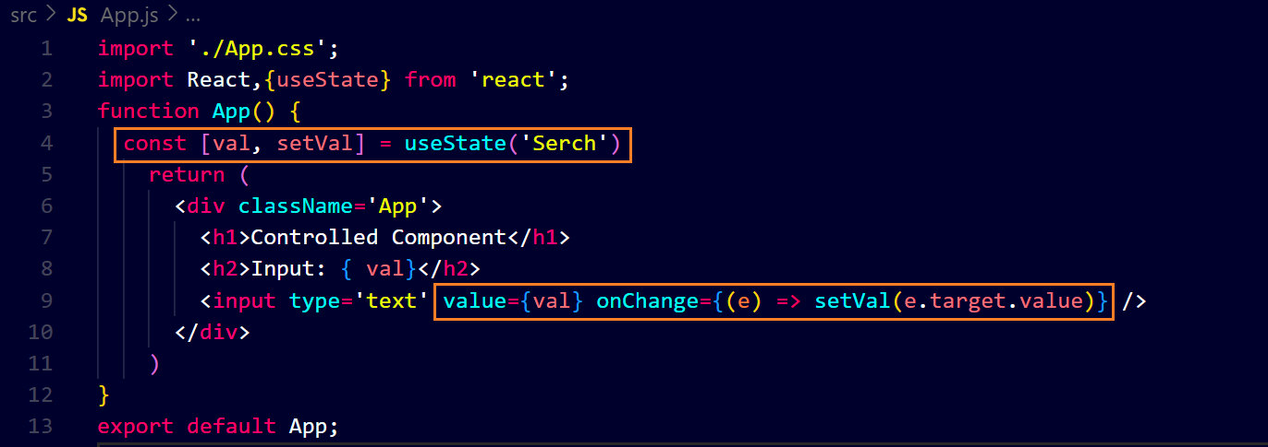output ↓**